IEEE ROBOTICS AND AUTOMATION SOCIETY EVENT CONDUCTED (EXECOM 2024)

1.DESIGN DUEL : FUSION 360 EDITION
Date: 01 March 2024
Mode:Online
Design Duel : Fusion 360 Edition was an engaging competition that focused on showcasing participants' skills in 3D modeling using Fusion 360 software. Organized by IEEE RAS SBC NSSCE, the event aimed to bring together enthusiasts and students passionate about design and engineering. Held on 01-03-2024 via online.The registration fee was 20 per head.There were 21 teams for the competitions and the competition provided a platform for participants to demonstrate their creativity, technical expertise, and problem-solving abilities in the realm of 3D modeling.
Participants were presented with various challenges ranging from conceptual design tasks to real-world engineering problems.The format included individual and team-based challenges, ensuring a diverse range of skills and perspectives were represented.The competition emphasized not only creativity but also technical proficiency. Participants leveraged Fusion 360's advanced features to create precise, functional models that met the specified requirements of each challenge.
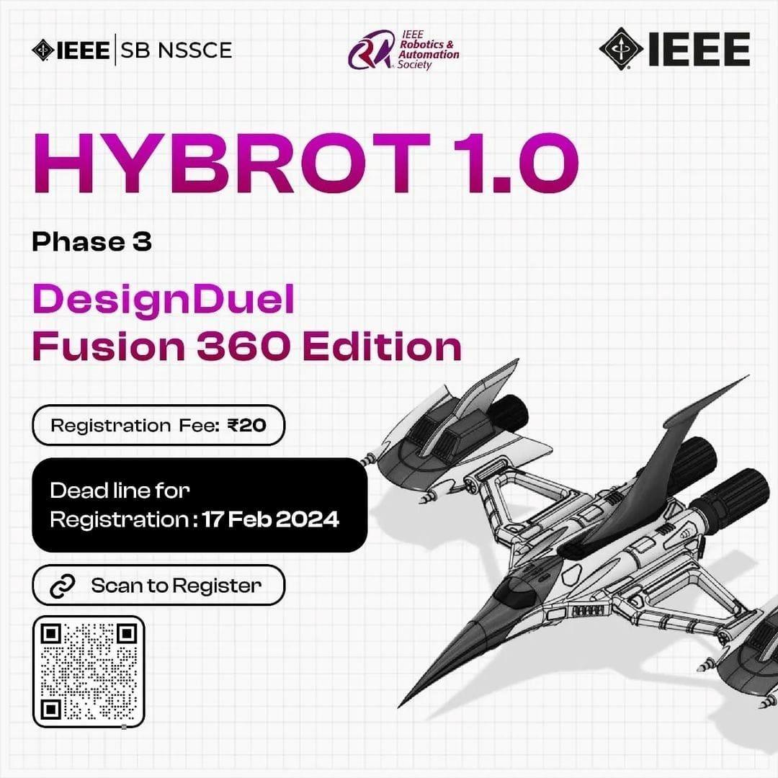

2.DRONE CRAFT
Date:4th March 2024
Speaker: Aero Knotz Drone India Pvt. Ltd
Venue: NSS College of Engineering
Engaging workshop on Drone craft was held on 4 March 2024 by Aero Knotz Drone India Pvt. Ltd in collaboration with PTIB and Student branch chapters VTS, ComSoc, RAS, IES, IAS and Wie AG NSSCE. The goal of the workshop was to give students practical experience in designing, building, and operating drones while also gaining insight into the wide range of companies that use drone technology. The workshop commenced with a thorough exploration of drone technology like various types of drones, including quadcopters, hexacopters, and other configurations, encompassing an in-depth analysis of its foundational components, intricate functionalities, and diverse applications across industries. Participants were immersed in a discourse highlighting the burgeoning significance of drones in sectors such as agriculture, surveillance, filmmaking, and disaster management, underscoring their pivotal role in modern-day operations..Throughout the assembly process, mentors engaged in interactive discussions, ensuring participants understood the importance of precision in the placement and connection of each component.As the workshop progressed, each group of participants successfully assembled and flew the drones they created. This hands-on experience provided invaluable insights into the practical aspects of drone operation, emphasizing the significance of the knowledge gained during the workshop. It not only provided practical insights into drone assembly but also fostered a collaborative learning environment. During the entire session, the focus was on investigating how drones could be used to solve modern problems and simplify everyday tasks. Drones are transforming a number of facets of modern life, including aerial photography, crop monitoring, search and rescue operations, and package delivery. This was highlighted by interactive discussions and real-world examples. The session gave participants invaluable insights into using drones as instruments for creativity and problem-solving in today's dynamic context by creating a hands-on learning environment .
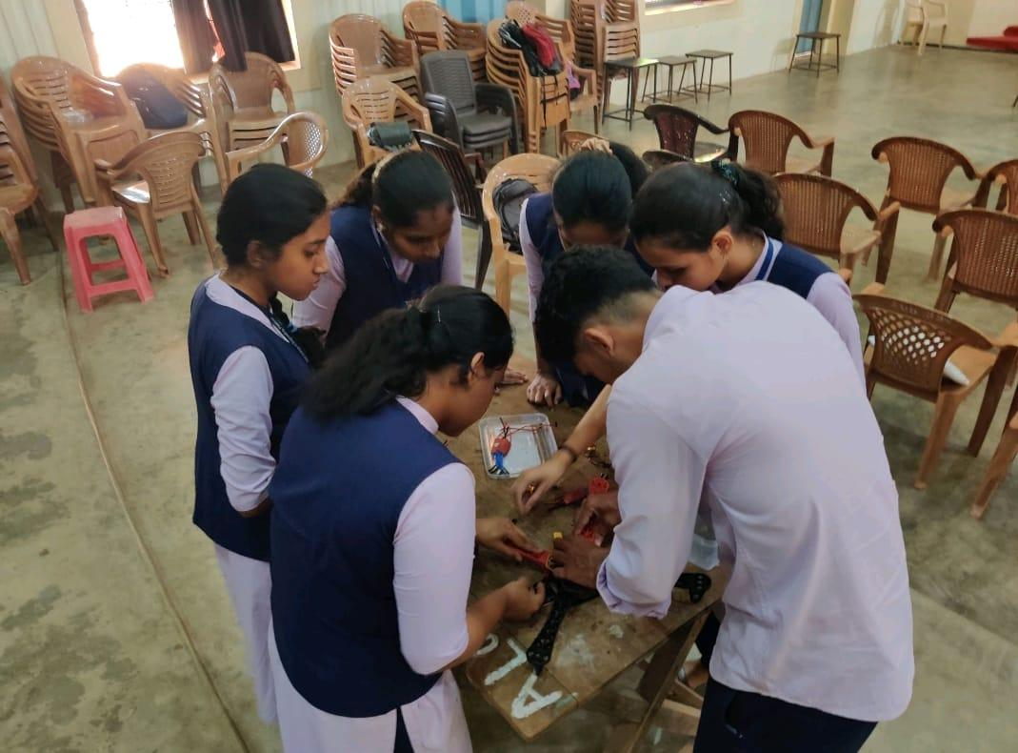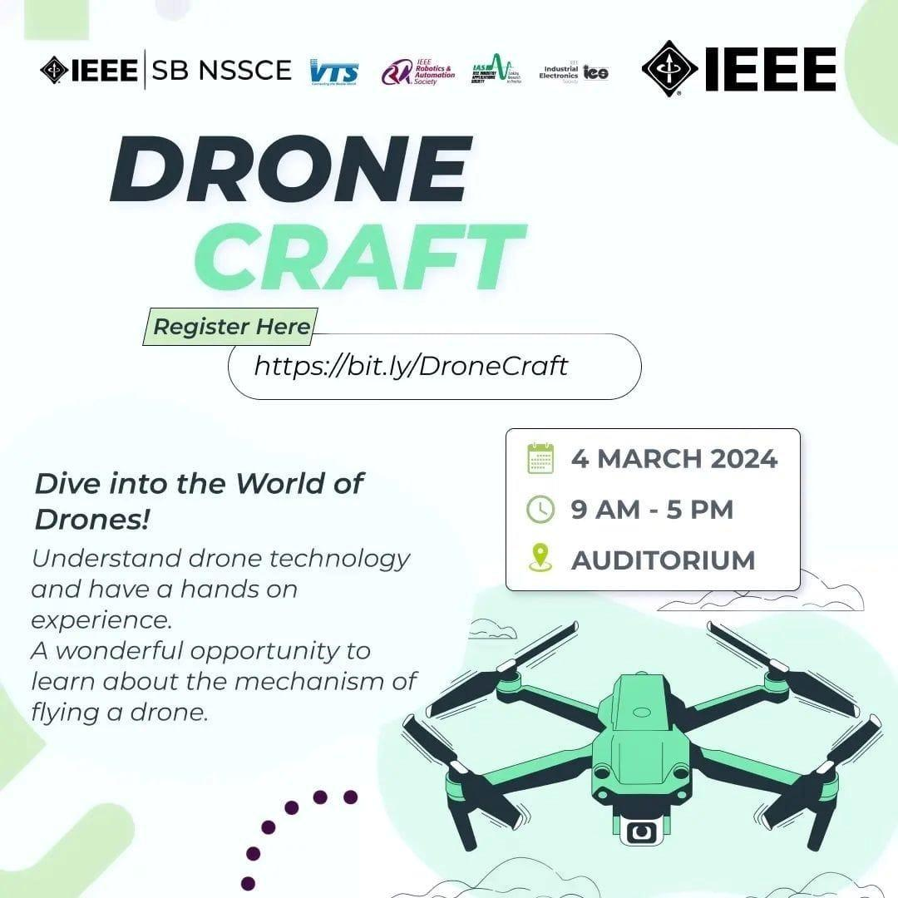

3.Charting Your Career: Insights into Data Analysis
Date:13 th April 2024
Speaker:Thoufiq Ameen Khan ,Data Analyst, CareStack
Platform: Google Meet
Charting Your Career: Insights into Data Analysis was a highly informative online session conducted by
IEEE RAS SBC NSSCE delving into the realm of data analysis. Hosted by the accomplished Data Analyst, Thoufiq Ameen Khan from CareStack, the event provided valuable insights and guidance for individuals aspiring to pursue a career in this field.Thoufiq Ameen Khan, drawing from his extensive experience at CareStack, shared practical advice and strategies for navigating the complexities of data analysis. He elucidated the importance of leveraging various tools and techniques to extract meaningful insights from data, emphasizing the critical role of data analysis in informing decision-making processes across industries.Throughout the session, participants gained a deeper understanding of the key concepts and methodologies employed in data analysis, ranging from data cleansing and manipulation to advanced statistical analysis and visualization techniques. Khan's expertise shone through as he elucidated real-world case studies and examples, illustrating how data analysis can drive business growth and innovation.Moreover, the session offered invaluable guidance on charting one's career path in data analysis, including tips for honing technical skills, building a robust professional network, and staying updated with the latest industry trends and technologies.
Attendees left the session empowered with newfound knowledge and actionable insights to kick-start or advance their careers in data analysis. "Charting Your Career: Insights into Data Analysis" served as a beacon for aspiring data analysts, offering them a roadmap to navigate the dynamic landscape of data-driven decision-making.
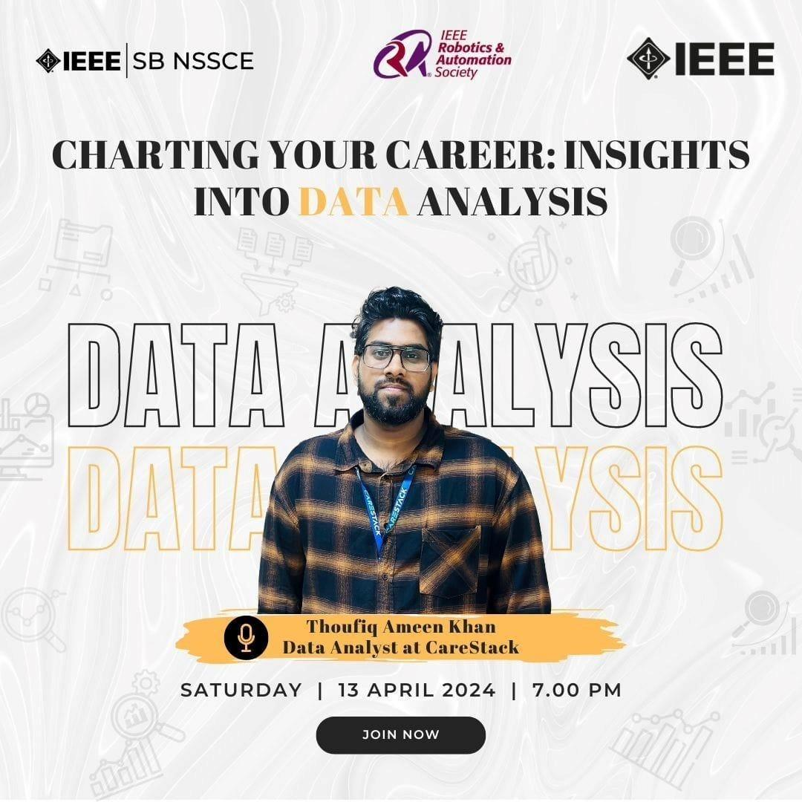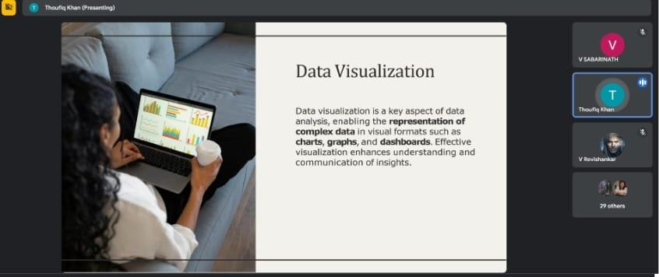

4.ROS WORKSHOP
Date: July 23rd to 24th and July 28th to 29th, 2024
Speaker: Athira Krishnan R
Platform: Google Meet
A four-day Robot Operating System (ROS) workshop was hosted by the IEEE RAS Kerala Chapter and co-hosted by eight RAS SBCs across Kerala, including RAS SBC NSSCE. Held online via Google Meet from July 23rd to 24th and July 28th to 29th, 2024, the workshop ran daily from 7:00 pm to 8:30 pm. The event was led by Athira Krishnan R, Treasurer of IEEE RAS KC, PhD Scholar at IITH, and Developer at TCS.
The workshop focused on the critical role of robots and the Robot Operating System (ROS), providing participants with both foundational knowledge and practical skills. It began with an introduction to robotics fundamentals, including kinetics, dynamics, mobile networks, and mobile robots, followed by setting up a basic ROS environment. Practical tools like Gazebo for simulation, ROS2 advancements, and Turtlesim for interactive learning were explored. Participants learned to create and understand URDF files for robot modeling, reviewed pre-written code, installed essential packages, and studied the importance of frames in ROS for coordinate transformations. Advanced sessions covered visualization and mapping using RViz and TurtleBot3 Cartographer, enhancing skills in sensor data integration, map generation, and navigation. The workshop concluded successfully with positive feedback and valuable practical knowledge gained by attendees.

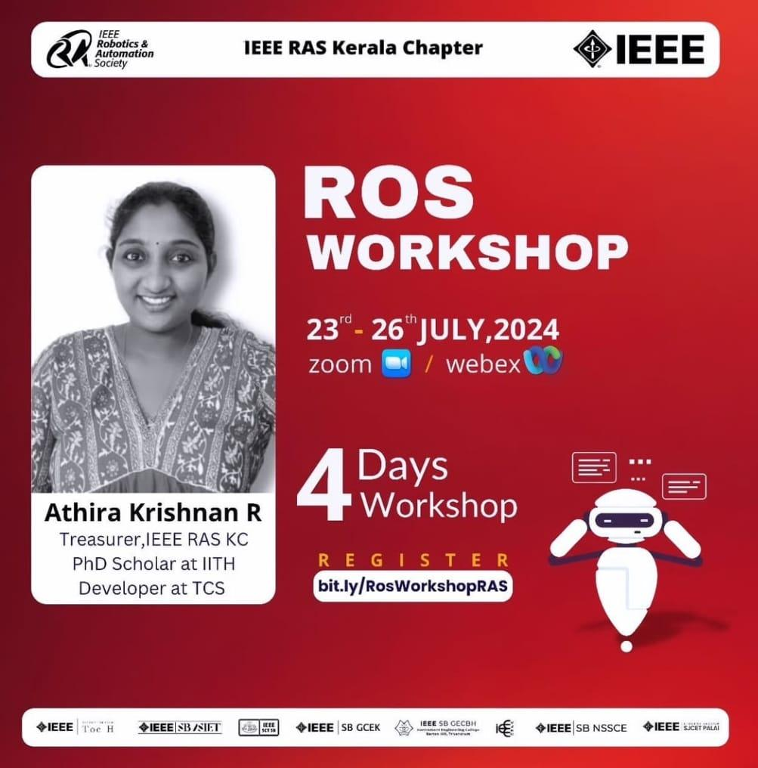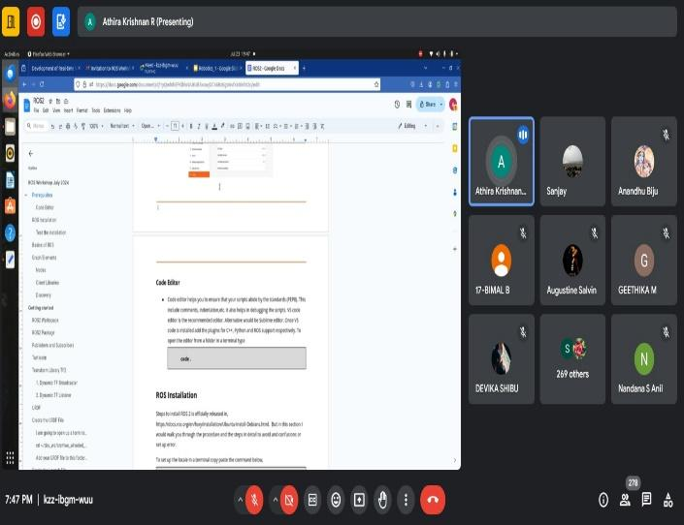

5.Haptics
Date:10th August 2024
Speaker:Dr Jee Hwan Ryu,Department of Civil and Environmental Engineering at KAIST, South Korea
Platform: Google Meet
The IEEE Robotics and Automation Society Student Branch Chapter (RAS SBC) of NSS College of Engineering successfully organized a Distinguished Lecturer Program on the 10th of August 2024. This highly anticipated event featured Dr. Jee-Hwan Ryu, a distinguished professor from the Department of Civil and Environmental Engineering at KAIST, South Korea. Dr. Ryu is also the Co-chair of the IEEE Technical Committee on Haptics, making him a highly regarded expert in the field.The program began with a brief introduction to the IEEE RAS SBC NSSCE and its mission to promote knowledge sharing and innovation in the field of robotics and automation. The session was then handed over to Dr. Ryu, who delved into the world of haptics—a technology that interfaces the digital and physical worlds by enabling tactile feedback.Dr. Ryu's presentation covered the fundamental principles of haptics, its applications in various fields such as medical robotics, virtual reality, and remote control systems, and the latest advancements in the technology. His session was not only informative but also highly engaging, as he made complex topics accessible to participants with varying levels of expertise.One of the key aspects of the program was the interactive nature of Dr. Ryu’s lecture. He encouraged questions throughout the session and provided detailed answers, ensuring that participants left with a deep understanding of the subject matter.The event was well-received by all attendees, who appreciated the opportunity to learn from a leading expert in the field of haptics. The feedback highlighted the clarity of Dr. Ryu’s explanations, the relevance of the topics covered, and the overall organization of the event.In conclusion, the Distinguished Lecturer Program was a resounding success, providing valuable insights into the field of haptics and inspiring participants to explore further in this cutting-edge area of technology. IEEE RAS SBC NSSCE looks forward to hosting more such events in the future to continue fostering knowledge and innovation in the robotics and automation community.

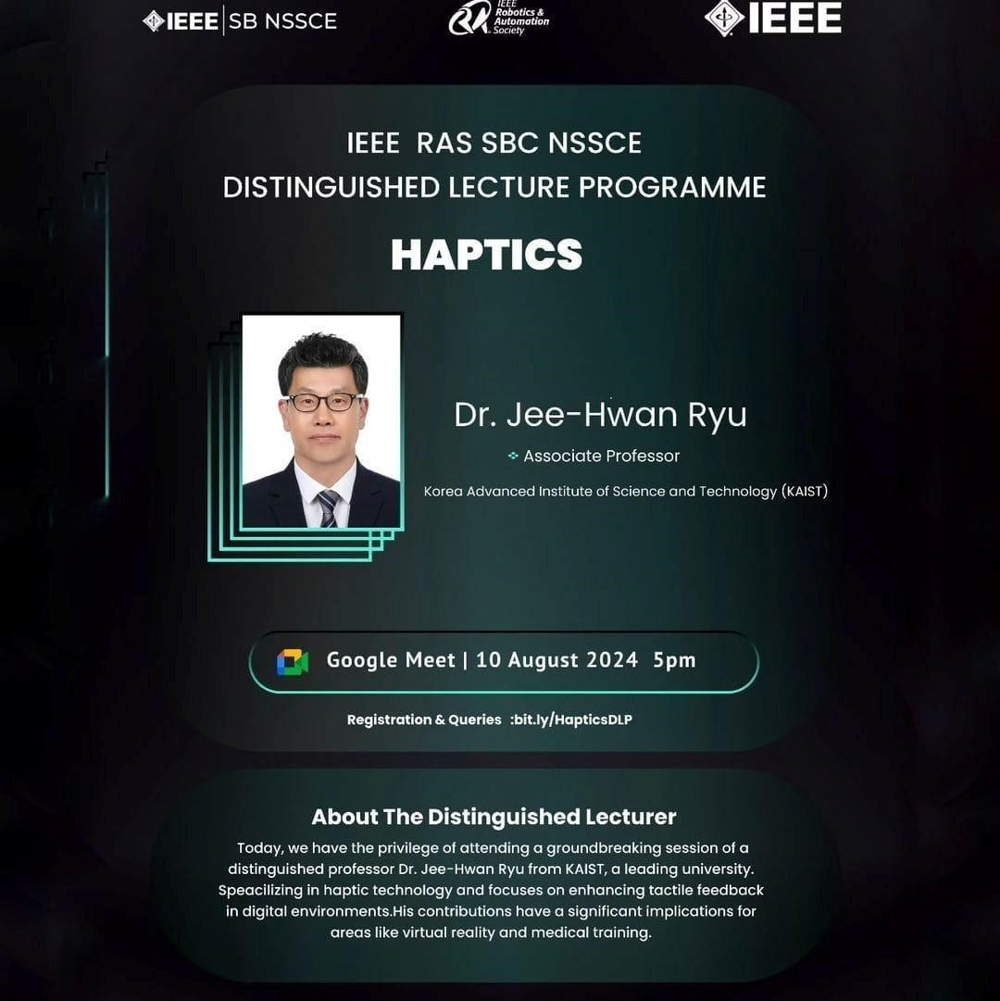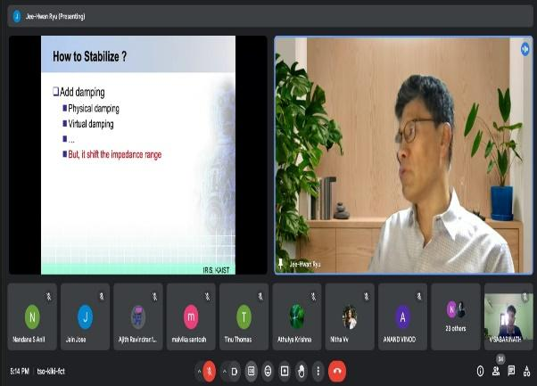

6.HYBROT 2.0: INTEGRATION OF AI IN PROJECT
Date:28th September 2024
Speaker:Sreedhar K S, Ex GDSC Lead at SCTCE Venue:NSS College of Engineering Palakkad
The AI workshop, held on 28th September 2024 at NSS College of Engineering, Palakkad as part of HYBROT 2.0, featured Sreedhar K S, Ex GDSC Lead at SCTCE, as the guest
speaker. The workshop introduced participants to the fundamentals of Artificial Intelligence, including key concepts like machine learning, neural networks, and data-driven decision-making.
After covering the core concepts, Sreedhar K S delved into Large Language Models (LLMs) like GPT, explaining their training processes and applications in natural language processing (NLP). Participants were given hands-on experience with LLMs, exploring their capabilities in text generation, translation, and question answering. This interactive session allowed attendees to grasp the inner workings of LLMs and their real-world use cases.
A key segment of the workshop focused on the Gemini Model, an innovative AI model that integrates multimodal capabilities by processing both visual and textual information. Sreedhar K S explained the creation and functionality of Gemini, demonstrating how it can be used in complex applications such as autonomous systems and interactive AI agents. The participants actively engaged in discussions on how such models could revolutionize fields like robotics,healthcare, and media, leaving the workshop with valuable insights into the future of AI.

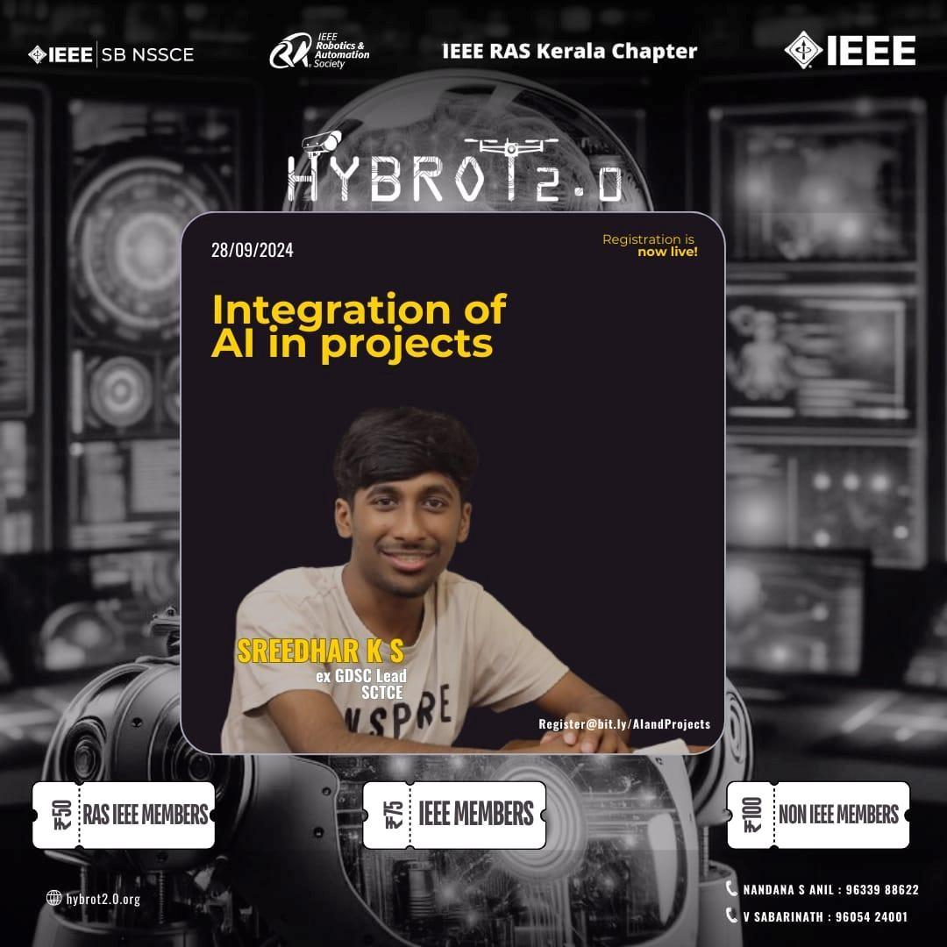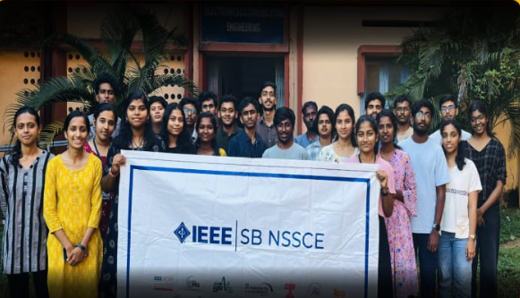

7.HYBROT 2.0 :Crafting Worlds with Blender
Date : 29th September 2024
Speaker: Pranav P Prasanth, Digital Artist
Venue: EC seminar hall NSSCE
IEEE RAS SB NSSCE in collaboration with IEEE RAS Kerala Chapter as a part of IEEE day 2024 celebration organized an event named Crafting Worlds with Blender, an exclusive workshop on the free and open-source 3D computer graphics software tool.
The session was led by Pranav P Prasanth,a famous digital Artist who shares his knowledge about the working of Blender software and the making of 3D graphics using this.He basically points out the importance of this software and how a person can make use of it in various kinds of projects. He also discussed the range of advanced modeling that can be done using Blender and about the wide range of tasks performed using this and allows one to create highly detailed and realistic 3D models.He explained in a simple and understandable manner about all of the topics associated with this software.
Around 30 enthusiastic participants actively engaged in the workshop, eager to gain valuable insights on the topic. Each and every participant got an idea about the working of Blender and motivated to use it furthermore in the future.
Overall, the session was a great success, inspiring students to explore the exciting and interesting world of Blender.
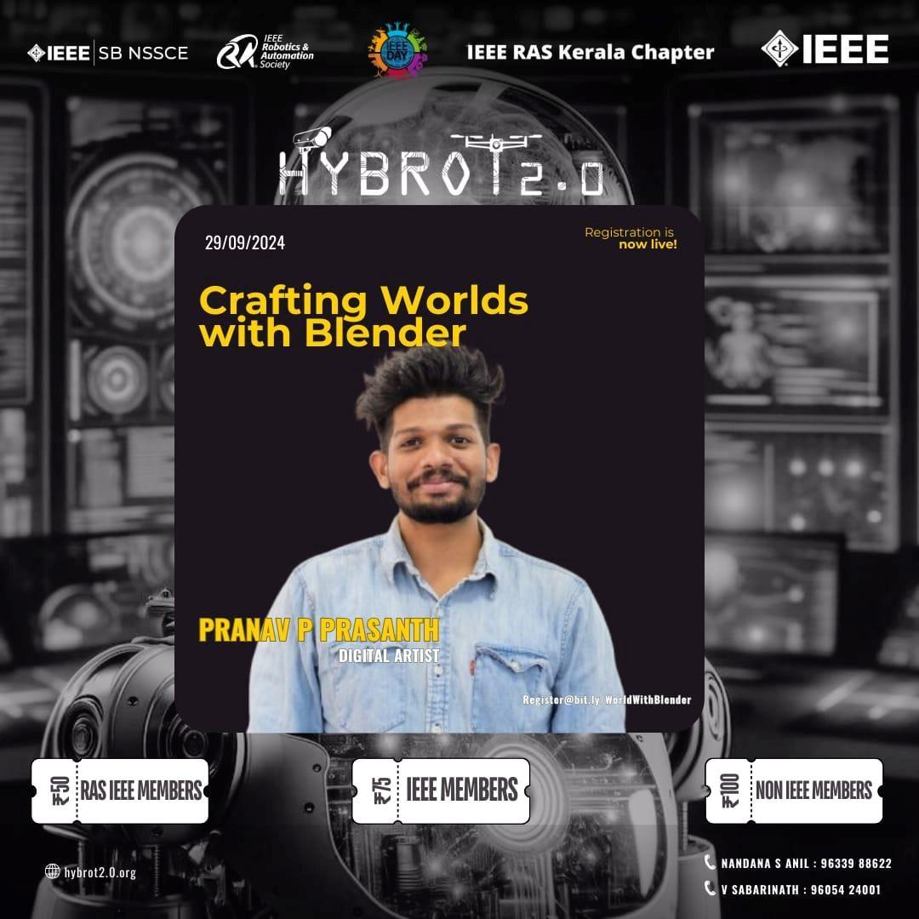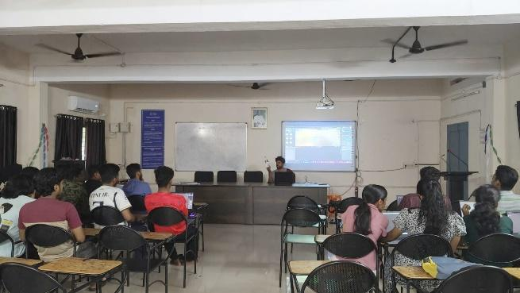

8.NAVIG8 MAZE SOLVING ROBOTS PHASE 1
Date :27/09/2024
Speaker: Govind S Warrier Embedded Software Designer,Swapp Design Private Limited
Platform: Google meet
The NAVIG8 MAZE SOLVING ROBOTS was organised by IEEE IES SBC and IEEE RAS SBC in collaboration with IEEE SB NSSCE as a part of Hybrot 2.0. It included phase 1 and phase 2.Phase 1 was a webinar session including introduction to maze Robotics algorithms and programming which provided the participants ability of problem solving skills and to explore the robotic world .The phase 2 was a hands-on session coordinated by RAS SBC.
- TOPICS COVERED:
1.Basic concepts of Arduino,syntax,basic programming
2.Ultrasonic sensor -principle working and application
3.DC motor interfacing
4.HC bridge motor controller.
5.Algorithms in maze solving robots.
NAVIG8 MAZE SOLVING ROBOTS PHASE 1 successfully achieved its objectives, providing participants with valuable knowledge and skills in maze robotics and programming.
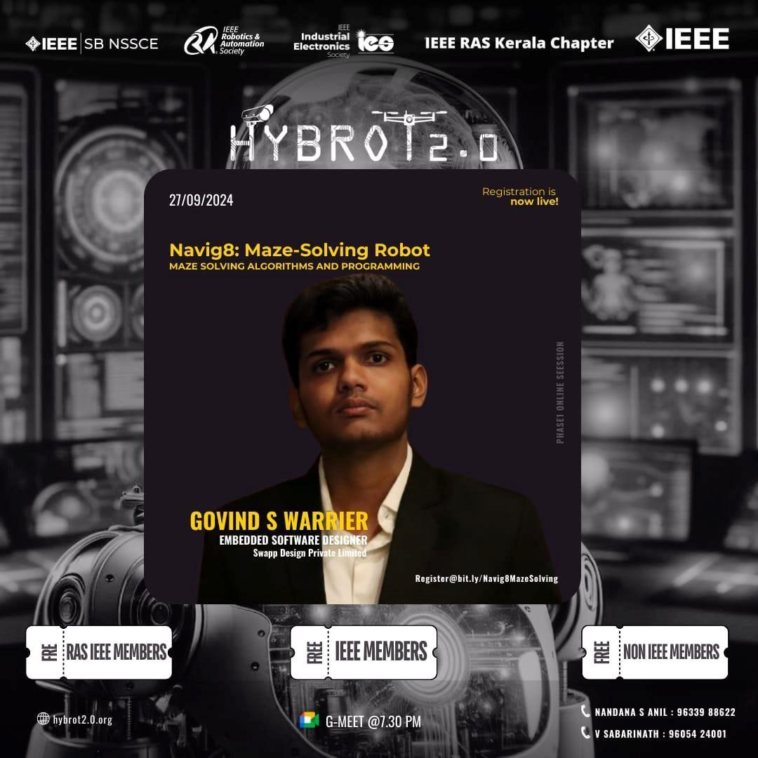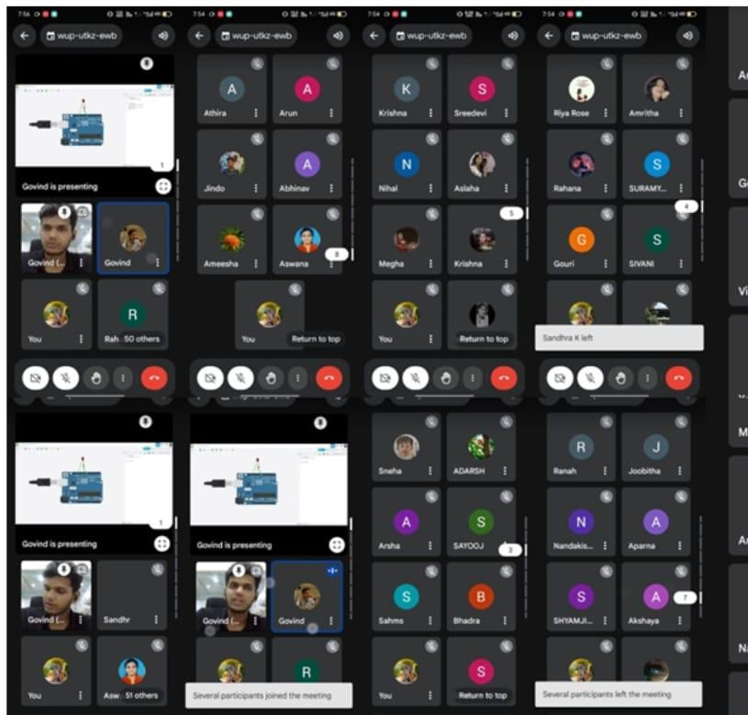

9.HYBROT 2.0 - Navig8 Maze-Solving Robot: Robot Assembly & Hands-on Training
Date: 02/10/2024
Speaker: Govind S Warrier Embedded Software Designer,Swapp Design Private Limited
Venue: NSS College of Engineering
Phase 2 of the NAVIG8 Maze Solving Robots program, organized by IEEE RAS SBC NSSCE in collaboration with IEEE IES SBC and IEEE SB NSSCE as a part of HYBROT 2.0, was a hands-on training session focused on the practical aspects of maze-solving robotics. This phase was designed to build on the foundational knowledge provided in Phase 1, giving participants the opportunity to assemble and program their own maze-solving robots.
The session provided a collaborative environment where participants could apply theoretical concepts from the previous webinar, interact with hardware components, and gain valuable practical experience in robot assembly and problem-solving in robotics.
OBJECTIVES:
- To provide hands-on experience in assembling and programming maze-solving robots.
- To familiarize participants with essential robotic components such as sensors, motors, and controllers.
- To reinforce the concepts learned in Phase 1 through real-world application.
- To develop practical skills in robotics, including troubleshooting and component interfacing.
- To foster teamwork and collaborative problem-solving skills in a lab environment.
ACTIVITIES AND TOPICS COVERED:
- Robot Assembly: Participants learned step-by-step assembly of maze-solving robots, including frame construction and component mounting.
- Wiring and Interfacing: Guidance was provided on connecting and interfacing components like ultrasonic sensors, DC motors, and H-Bridge motor controllers.
- Programming and Algorithm Implementation: Participants implemented maze-solving algorithms using Arduino, programming their robots to navigate and make decisions based on sensor feedback.
- Troubleshooting and Testing: The session included troubleshooting exercises, where participants identified and resolved common issues in robotic systems. Each robot was tested in a simple maze setup to assess performance.
- Feedback and Enhancements: Participants received feedback on their implementations and suggestions for improving robot responsiveness and accuracy.
OUTCOME:
The Phase 2 session successfully achieved its objectives, providing participants with hands-on experience in robotic assembly and programming. The practical exposure reinforced participants’ understanding of maze-solving algorithms and robotic components. Many participants expressed interest in pursuing further robotics projects and were enthusiastic about the skills they had acquired.
CONCLUSION:
The NAVIG8 Maze Solving Robots Phase 2 session was an invaluable practical learning experience, building on the foundational knowledge from Phase 1 and solidifying participants’ understanding through real-world application. The success of Phase 2 reflects the participants' dedication and the effective guidance provided by IEEE RAS SBC NSSCE. This event demonstrated the potential of hands-on robotics training to inspire and prepare future robotics enthusiasts and professionals.

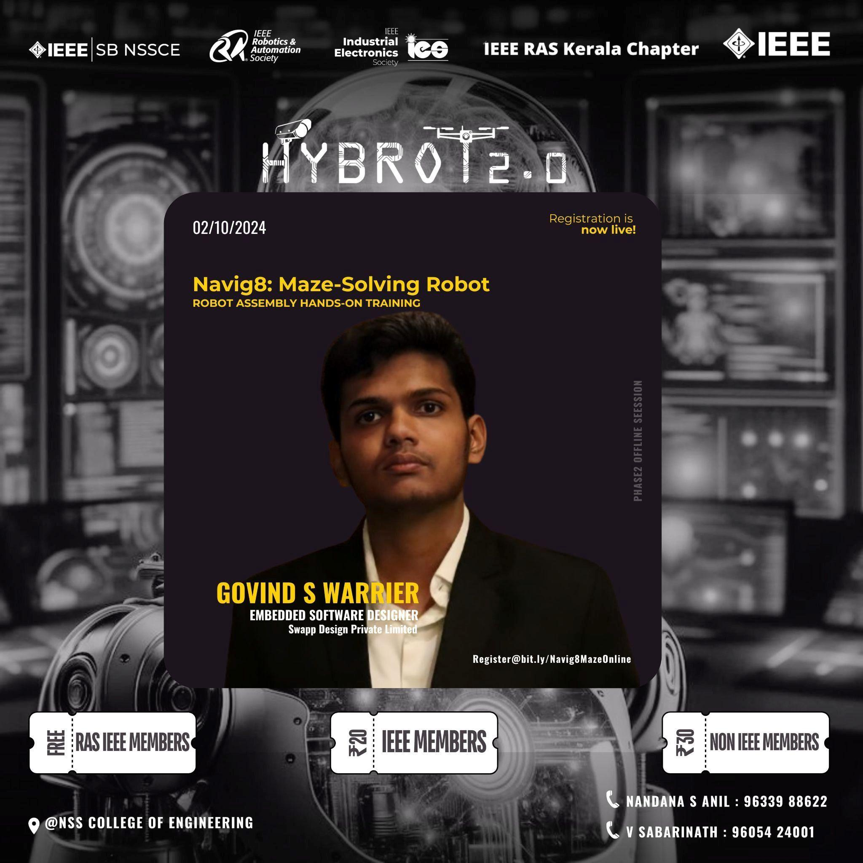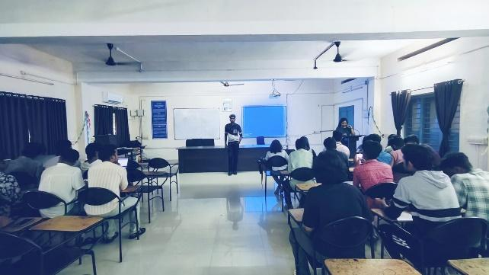

10.HYBROT 2.0 : Automate with RPA
Date:26th October 2024
Speaker: Mariya Jolly, RPA Developer,Niico.AI
Platform:Google meet
The "Automate with RPA" session, conducted online on 26th October 2024. by Mariya Jolly,an RPA
Developer at Niico.AI, provided participants with an engaging introduction to Robotic Process Automation (RPA). Mariya outlined the fundamentals of RPA, explaining how it streamlines repetitive tasks by mimicking human actions in digital workflows.
Throughout the session, Mariya demonstrated key RPA tools and technologies, showcasing how automation can reduce errors, enhance productivity, and free up resources for higher-value tasks. Participants observed live examples of simple RPA bots in action, and Mariya shared best practices for developing efficient automation solutions.
The session encouraged questions and discussions, fostering a deeper understanding of RPA's potential applications across industries. This interactive, informative session left participants inspired to explore RPA as a tool for innovation in their workflows, equipping them with the foundational knowledge to start automating processes in their own environments.

